**Chapter 3**

**3.1: Since Ancient Times Astronomers have Studied the Motions of the Planets**

**Early Astronomy:**

* Early Astronomers believed that the Earth was the center of our Solar System, accepting the *Geocentric* model.
* Geocentric Model:
  + The idea that the earth is the center of the solar system
  + Believed for about 1,500 years
  + Came into question when the visible solar system appeared to exhibit retrograde motion
* Retrograde Motion:
  + Objects in the sky would appear to turn around, move westward for a bit, then return to normal
  + This creates a problem for the geocentric model, suggesting that the planets stop orbiting at some point and turn around
* Ptolemy modified the geocentric model to include epicycles, or smaller circles that the planets travel in while orbiting the earth
  + These epicycles explained retrograde while maintaining the geocentric model

**Copernican Revolution**

* Nicolaus Copernicus
  + Developed and popularized the heliocentric model of the solar system, in which the sun is in the center and the planets orbit it
  + With help from Brahe, Galilei, Kepler, and Newton, this model became widely accepted
* Explanation of retrograde motion
  + With the heliocentric model, retrograde motion is explained as the earth “overtaking” the other planets in orbit, giving the illusion that that planet is moving backwards
* Additionally, Copernicus developed estimates to the distance of earth-planet and earth-sun, as well as relative orbit times with surprising accuracy

**Kepler’s Laws**

* Kepler, a protégé of Tycho, continued his masters work and developed laws that explain planetary motion.
* These laws are empirical: they use prior data to make future predictions, but don’t include underlying theory of why these objects behave like they do
* Kepler’s Laws:
  + 1: The orbit of a planet is an ellipse with the Sun at one focus.
    - 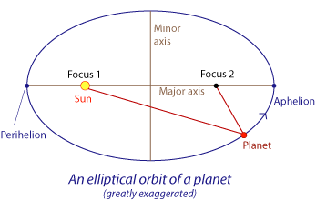Length of semimajor axis of elliptical orbit dependent on the distance of the planet from the sun (i.e. the farther away from the sun, the longer the axis and the more “elliptical” it looks)
  + 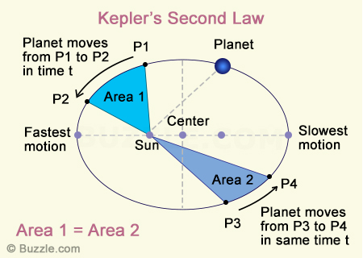2: (AKA the Law of Equal Areas) states that the area swept out by a planet during a specific time interval is always the same, regardless of the location of the planet in its orbit
  + 3: states that the period of a planet’s orbit squared is equal to its average distance from the Sun cubed

**3.2: Galileo Was the First Modern Scientist**

* Galileo was the first scientist to use telescopes to make major strides in astronomy
* He made 4 main discoveries during his time:
  + There are 4 “Galilean Moons” that orbit Jupiter, showing that not everything in the solar system orbited the earth
  + Venus underwent phases similar to our moon, allowing further proof of a heliocentric model of the solar system
  + He also made strides in physical experimentation and gravity

**3.3: Newton’s Laws Govern Motion**

**Newton’s First Law**

* States that an object in motion tends to stay in motion, in the same direction, until a net force acts upon it. Also an object at rest will stay at rest until a net force is acted upon it

**Newton’s Second Law**

* If a net force acts on an object, then the object’s motion changes
  + This law also goes on to explain velocity and acceleration

**Newton’s Third Law**

* States that forces always come in pairs, and the forces of a pair are always equal in strength but opposite in direction

**Newton’s Laws and Motion**

* Think of an astronaut in space floating. If he throws a wrench in one direction, Newton’s laws explain that he will move in the opposite direction of the wrench at the same speed as the wrench

**3.4: Gravity is a Force between any Two Massive Objects**

**Gravity, Mass, and Weight**

* Gravitational force
  + The mutually attractive force between any two objects
  + Typically called weight
  + Near the Earth, the gravitation force (gravitational acceleration, or *g*) is about 9.8 m/s2
  + Combining Newton’s Laws with this idea, you can come up with equations to model this force

**F = mg**

**Newton’s Law of Gravity**

* Combining Newton’s third law to gravity, he came up with the idea that if an object is falling to the Earth, then the Earth is “falling” up towards that object with the same amount of force
  + We don’t notice this because Earth has a LOT of inertia (Newton’s first law)
  + This idea can be modeled by proportions

**Gravitational force = Something x Mass of Earth x Mass of object**

**G = km1 m2**

* + Yet distance also plays a factor, and Kepler/Newton realized that the *inverse square law* applied here. So:
 $$F=G\frac{m_{1}m_{2}}{r^{2}}, G=6.67×{10}^{-11}$$

 + G in the above equation is the *Universal Gravitational Constant*, basically the proportionality constant that applies to all gravitational relations between objects

**3.5: Orbits are One Body “Falling Around” Another**

**Newton Explains Kepler**

* Using Newton’s laws of motion and gravity, he predicted the paths that planets should follow around the sun
  + Planetary orbits should be ellipses with the Sun at one focus
  + Planets should travel faster when closer to the Sun
  + The square of the period of the orbit should equal the semimajor axis cubed (in appropriate units)
* Basically, Newton’s law of gravitation *predicted* that the planets should orbit the Sun in the way that Kepler’s empirical laws described

**Gravity and Orbits**

* In 1957, Russians used rockets to propel Sputnik, an object about the size of a basketball, up until Earth’s atmosphere was so thin that air resistance didn’t matter. This allowed Newton’s laws to take actual effect. Sputnik was essentially “falling” around the earth
* This “falling” around an object is known as *orbit*
  + This explains why astronauts float in space. It is because Earth’s gravity is keeping them in freefall around Earth, and according to Newton, all objects fall the exact same in the absence of outside forces (air resistance), and thus the floating effect
* When an object is falling around another object, the less massive object is called a *satellite*

**Centripetal Force and Circular Velocity**

* Uniform Circular Motion further describes orbit, but only when the orbiting object is moving at a specific speed, known as its **circular velocity**

**The Shape of Orbits**

* As long as a satellite’s orbit remains elliptical, no matter how eccentric, the orbit is called a *bound orbit*, i.e. it is bound by Earth’s gravity
* There is a point of no return in terms of orbiting velocity, called the *escape velocity*
  + Once this velocity is reached, the objects obit is called an *unbound orbit*